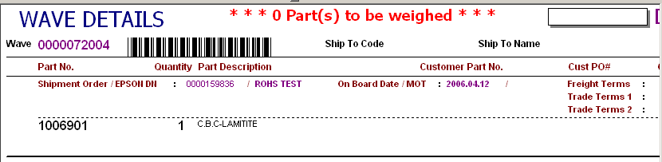


Pls add an distinctive logo beside the special parts to alter the packer to take preventative action .
Eg a Rabit

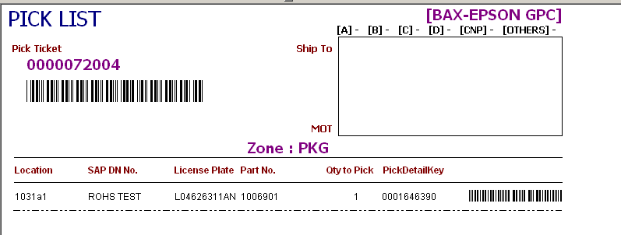
The format of special LP will be defined as “LxxxxxxANDREW”. So pls highlight such LP at row level and with warning message shown on the header area in bigger font size and bold.
In addition, kindly extend the length of the LP in order to show the full description.

Please approach to Admin

